

***The Twenty-Third Psalm***

*The Lord is my shepherd; I shall not want.*

*He maketh me to lie down in green pastures;*

*He leadeth me beside the still waters.*

## *He restoreth my soul; He leadeth me in the*

paths of righteousness for His name’s sake.

*Yea, though I walk through the valley of*

*the shadow of death, I will fear no evil;*

*for thou art with me, thy rod and*

*thy staff they comfort me.*

*Thou preparest a table before me in*

*the presence of mine enemies;*

*Thou anointest my head with oil;*

*My cup runneth over.*

*Surely goodness and mercy shall follow*

*me all the days of my life;*

*and I will dwell in the house*

*of the Lord forever.*

**Witness To The Resurrection**

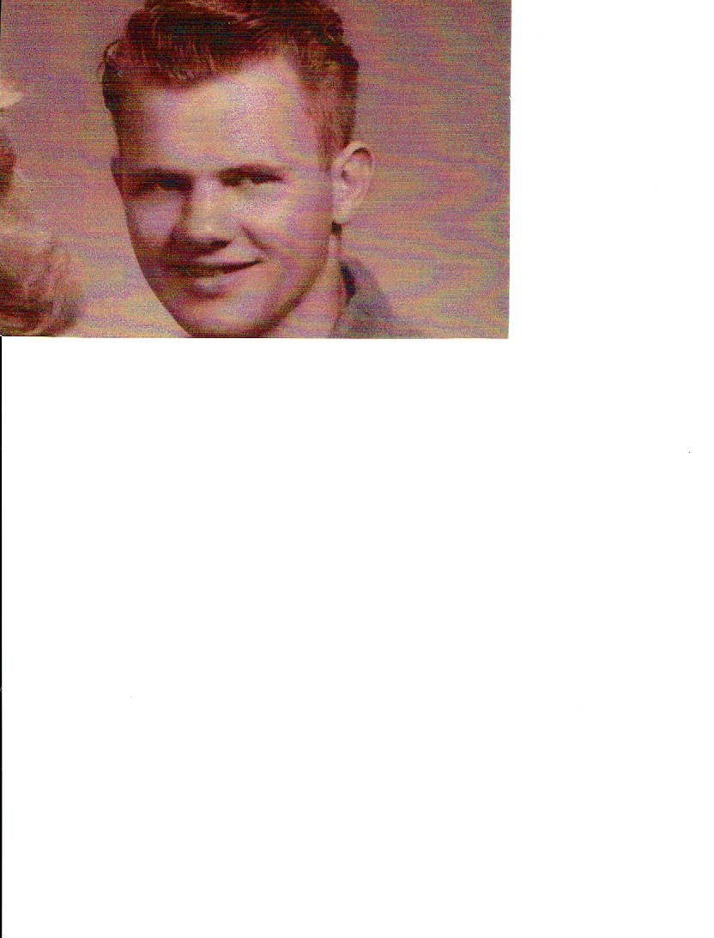

*Benediction

*Postlude

***\*****Please stand if you are able.*

**Stanley Willard Skidmore, Sr.**

**December 25, 1943 – October 4, 2021**

**October 7, 2021**

**4:00 p.m.**

**Wallace Presbyterian Church**

A WITNESS TO THE RESURRECTION

Prelude

Processional Hymn #611 *“Joyful, Joyful, We Adore Thee”*  HYMN TO JOY

Call to Worship

Prayer

Old Testament Lessons

Ecclesiastes 3:1-15 Psalm 23 (Unison)

Special Music “*It Is Well With My Soul”*

New Testament Lessons

John 10:1-10 John 11:17-27 1 Corinthians 15:50-58

Special Music *“This Little Light of Mine”* *arr.* by Mark Hayes

Meditation *“The Gift of Life”*

Sharing of Memories from Stan’s Family

Prayers of Thanksgiving and Intercession with The Lord’s Prayer

*Our Father, who art in heaven, hallowed be thy name. Thy kingdom come, thy will be done, on earth as it is in heaven. Give us this day our daily bread; and forgive us our debts as we forgive our debtors. And lead us not into temptation, but deliver us from evil. For thine is the kingdom and the power and the glory forever. Amen.*

Affirmation of Faith: The Apostles’ Creed

*I believe in God the Father Almighty, Maker of heaven and earth, And in Jesus Christ his only Son our Lord; who was conceived by the Holy Ghost, born of the Virgin Mary, suffered under Pontius Pilate, was crucified, dead, and buried; he descended into hell; the third day he rose again from the dead; he ascended into heaven, and sitteth on the right hand of God the Father Almighty; from thence he shall come to judge the quick and the dead. I believe in the Holy Ghost; the holy catholic Church; the communion of saints; the forgiveness of sins; the resurrection of the body; and the life everlasting. Amen.*

Prayer of Commendation

Special Music *“Come to Jesus”*

Benediction

Military Honors

Postlude

#### WORSHIP LEADERS

Dr. Philip K. Gladden

Minister

Mr. Stanley Willard Skidmore, Jr.

Son

Mrs. Karla U. Casteen

Organist/Pianist

Mrs. Vera Skidmore Simpson

Pianist

Mr. Randy Bittner

Baritone

Mr. Ryan Southerland

Trumpeter

HONORARY PALLBEARERS

Ronald Skidmore

Garrett Skidmore

Grant Skidmore

Royal Johnson

Patrick Rivenbark

Mickey Whaley

Michael Whaley

Bill Marks

Jimmy Casey

Firemen of the Wallace Volunteer Fire Department

In lieu of flowers, memorial contributions may be made directly to Vidant Health Foundation, Attn: Transplant Services, P.O. Box 8489, Greenville, NC 27835-8489.

The congregation is invited to greet Stan’s family in the Fellowship Hall following the worship service. Please observe all COVID-19 safety protocols.