



WALLACE PRESBYTERIAN CHURCH
205 West Main Street ● Wallace, North Carolina 28466
(910) 285-2808
Visit our Website: www.wallacepresbyterian.com

We support Presbyterian Church (USA) mission co-workers,
Rev. Dustin and Sherri Ellington, in Lusaka, Zambia, Africa.

Please silence your cell phones. *All who are able may stand.

THE SERVICE FOR THE LORD’S DAY
Fourth Sunday of Advent

December 22, 2019 11:00 A.M.

GATHERING OF GOD’S PEOPLE

Prelude

Welcome and Announcements
(During this time the friendship pads are passed to be signed.)

Minute for Mission

Lighting the Fourth Advent Candle Love
Elders Linda Burroughs and Christy Johnson

Congregational Choral Call to Worship
“While We Are Waiting” Cason, 1986
While we are waiting, come. While we are waiting, come.
Jesus, our Lord, Emmanuel, while we are waiting, come.

Opening Sentences Elder Christy Johnson
Leader: We are always looking for evidence that God is with us.
All: That sign is in the One to come--the One that God is sending.
Leader: We want to know for sure that everything is in God’s care.
All: And so we cry to the heavens in our distress. Our cries are heard! God is responding in love and hope.
Leader: Let us come before God with expectant hearts and spirits!
All: Let us be ready to receive the blessed gift of the Savior. Amen.

*Hymn #110 "Love Has Come” BRING A TORCH

The congregation is asked to remain silent during the prelude as a time of prayer and meditation.

“God loves each of us as if there were only one
of us.”
St. Augustine (354 - 430 A.D.), Christian theologian and Bishop of Hippo in North Africa

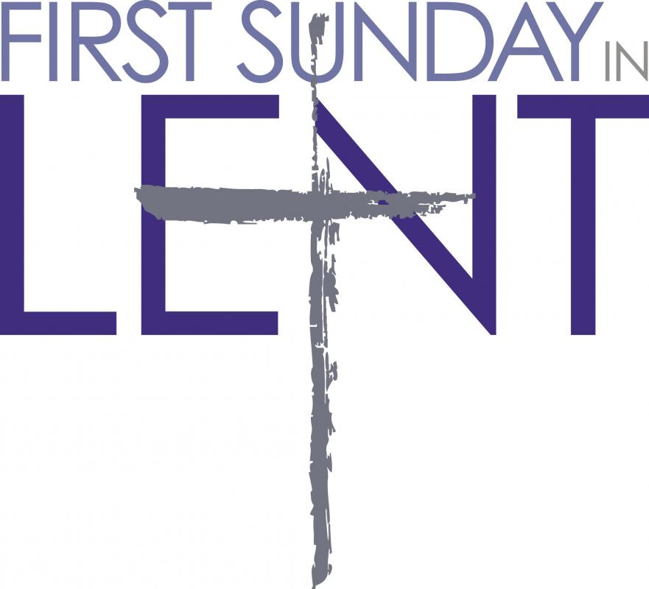


*Unison Prayer of Confession
We confess, Gracious God, that we have not always turned to you for guidance. At times, we have allowed the world’s time to dominate your time. Forgive us for our sins of hurriedness and impatience. Forgive us when we have slumbered instead of remaining alert, waiting and watching for you. Forgive us for allowing the world’s fears to become our fears. Shine upon us this Advent season so that we may be restored unto you. Guide us into your time. As we call upon your name, hear our prayers and give us life. In the name of Jesus Christ, we pray. .

(A time for silent prayers of confession . . .)

*Responsive Assurance of Pardon
Leader: The light of God’s love shines upon each of us in the gift of God’s love, Jesus Christ. This is given for you. Rejoice! You are loved by God, now and forever.
All: Thanks be to God for his indescribable gift of Jesus Christ. We give thanks that in Jesus, Emmanuel, God is truly with us.

*Gloria Patri Glory Be to the Father
Glory be to the Father, and to the Son, and
to the Holy Ghost; as it was in the beginning,
is now, and ever shall be, world without end. Amen, amen.

PROCLAIMING GOD’S WORD
Children's Sermon

Anthem "Mary Had a Baby" Lloyd Larson, 2016
David Sanderson, solo
Mary had a baby, my Lord. What did she name him, my Lord?
She named him King Jesus, my Lord. Where was he born, my Lord?
Born in a manger, my Lord. O come, let us adore him, Christ the Lord.
Mary had a baby, my Lord. He is Christ the Lord!

Prayer for Illumination
Speak to us, Lord. Speak to us in the waiting, the watching, the hoping, the longing, the sorrow, the sighing, the rejoicing. Speak to us by your Word in these Advent days, and walk with us until the day of your coming. Amen.

Today’s Prayer of Confession for the Fourth Sunday of Advent is taken from the Discipleship Ministries of the United Methodist Church.

“Love came down at Christmas; love all lovely, love divine; love was born at Christmas, stars and angels gave the sign.”
Christina G. Rossetti,
19th century
English poet


Epistle Lesson 1 John 4:7-21 Elder Christy Johnson
+Page 991

*Hymn #108 “Of the Father's Love Begotten" DIVINUM MYSTERIUM

Epistle Lesson Philippians 2:5-11 +Page 954

Gospel Lesson Matthew 1:18-25 +Page 783

Sermon “The Name That is Above Every Name” Dr. Philip K. Gladden

A Time for Silent Reflection

Pastoral Prayer with the Lord’s Prayer

GIVING THANKS TO GOD

Presentation of Tithes and Offerings

Offertory

*Doxology and Prayer of Dedication
Praise God from whom all blessings flow;
Praise Him all creatures here below;
Praise Him above ye heavenly host;
Praise Father, Son, and Holy Ghost. Amen.

*The Affirmation of Faith: From “A Declaration of Faith” of the Presbyterian Church (U.S.A.)
Jesus, the long expected Savior, came into the world as a child,
descended from David, conceived by the Holy Spirit, born of Mary,
a virgin. He lived as a Jew among Jews. He announced to his people the coming of God's kingdom of justice and peace on earth. We affirm that Jesus was born of woman as is every child, yet born of God's power as was no other child. In the person and work of Jesus, God himself and a human life are united but not confused, distinguished but not separated. The coming of Jesus was itself the coming of God's promised rule. Through his birth, life, death, and resurrection, he brings about the relationship between God and humanity that God always intended.

*Hymn #121 “O Little Town of Bethlehem" FOREST GREEN

*Benediction

Congregational Choral Benediction
“Go, Tell It on the Mountain” Spiritual, 19th century
Go tell it on the mountain, over the hills and everywhere;
Go tell it on the mountain that Jesus Christ is born!

*Postlude
*All who are able may stand. +The page number in the pew Bible.

“A baby, a manger, a bright and shining star; A shepherd, an angel, three kings from afar; A Savior, a promise from heaven above, The story of Christmas is filled with God’s love.”

“For God so loved the world that he gave his only Son, so that everyone who believes in him may not perish but may have eternal life.”
John 3:16

“God’s love was revealed among us in this way: God sent his only Son into the world so that we might live through him. In this is love, not that we loved God but that he loved us and sent his Son to be the atoning sacrifice for
our sins.”
1 John 4:9-10







ADVENT WREATHS

These Wreaths were bought for the Church during Advent Season and given in honor and memory of the following loved ones by the names listed below.

In memory of Anthony DiDomenico
Given by Charley & Harriet Farrior

In memory of our Fathers..Ben Hanson & Lowell Rasmussen
Given by Dean & Gerri Hanson

In memory of Lacey Elizabeth Johnson
Given by Tommy & Mary Glyn Johnson

In memory of our parents Flora Long & Bill & Gertrude Vanderwel
Given by David & Brenda Long

In memory of Joe Williams
Given by Danielle, Jim, Elizabeth & James Sills

In grateful memory for Philip Longest
Given by Georgia Longest & family

In memory of Mr. & Mrs. Edward F. Johnston, Sr., and The Rev. Edward F. Johnston, Jr.
Given by C.J. & Dotsi Caproni

In memory of Dr. John D. Robinson, Sr.
In memory of Dr. John D. Robinson, Jr.
In memory of Ruth Vann
Given by Dan & Tanya Robinson

In memory of Virginia "Sit" Knowles
In memory of Harry "Toots" Carlton
In memory of Judy Wells Holley
Given by Greg & Geneva Maready

In honor of the Music Ministry at Wallace Presbyterian Church
Given by Greg & Geneva Maready

The Chrismon Tree is given to the Glory of God and in memory of Harry "Toots" Carlton and William "Bill" Saunders.

Sunday, December 22 FOURTH SUNDAY OF ADVENT: LOVE
9:40 am Opening Assembly
10:00 am Sunday School
11:00 am Worship
Tuesday, December 24 7:00 pm CHRISTMAS EVE Candlelight Communion Worship Service
Wednesday, December 25 MERRY CHRISTMAS! Church Office Closed
Thursday, December 26 Church Office Closed
Sunday, December 29 9:40 am Opening Assembly
10:00 am Sunday School
11:00 am Worship
Thursday, December 26-Wednesday, January 1 Minister on Vacation

* We will celebrate the sacrament of the Lord’s Supper during our Christmas Eve Candlelight worship service on Tuesday, December 24. All are welcome at the table. We will also celebrate the sacrament of the Lord’s Supper during worship on Sunday, January 5, 2020.

* The church office will be closed Wednesday, December 25, 2019 - January 1, 2020.
Cheryl Brinkley, church secretary, will be on vacation December 24, 27, 30, and 31. Philip Gladden will be on vacation December 26 - January 1.

* Wayne Casteen, Church Treasurer, will make the final 2019 deposit on Monday, December 30. If you would like for your final contributions to be credited to 2019 for tax purposes, please submit them by Sunday, December 29. Thank you for your faithful generosity!


The poinsettias in the sanctuary for the month of December are given in loving memory of Jane Currie Barenborg by her husband Bill Barenborg and their children MaryBeth, Bill and Kristen. Jane is the granddaughter of William Currie, for whom the Currie Building is named.

Join us Christmas Eve
For a
Candlelight Communion Service
Tuesday,
December 24, 2019
7:00 PM


GREETERS
12/22: Rick & Nettie Batchelor
12/29: Dave & Gloria Wells

Dan Robinson, Leader
Harvey Knowles Chuck Farrior
Cameron Lee Joyce Ange


12/22: Nell Sloan & Madelyn Coombs
12/29: Leah & Camryn Fussell

 YOUTH WORSHIP LEADERS
12/22: Madelyn & Robert Coombs
12/29: Mason & Nate Diers

Opening Church Building
December 16-31: David Long

Andrea Casteen (cancer treatments), Jeff Cavenaugh (stage 4 lung cancer), Obbie Clemmons (recovering from hip surgery), Andrew DeNatale (Mary Carone's brother), Joe Dormagen (Verlie Wells’ son-in-law), Shella Farrior (recovering from surgery) George Hatch (cancer treatments), Family of Erin Sanderson Haux who died on 11/19 (long-time friend of Gerri Hanson),Candace Knowles (recovering from hip surgery), Hill Lanier, Frank Lettieri, (cancer treatments), Amy Moss (breast cancer, sister of Debbie Thomas), Jennifer Raynor (Postural Orthostatic Tachycardia Syndrome), Judy Robinson, Rodney Rogerson (Kidney Transplant, friend of Nell Sloan), Joe Tillman, (chemotherapy treatments), Ronnie Watson (non-Hodgkins Lymphoma, stem cell transplant), Andy Wells (Headmaster at HCA-Neuromyelitis Optica), Verlie Wells-Rosemary, Lee Woodard family, Members and friends in the armed services: Jason Payne. William Krupitzer-(Linda Burroughs nephew).
(When you request a name to be put on the prayer list, please notify the church office when you wish it to be taken off).

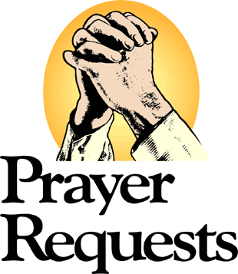

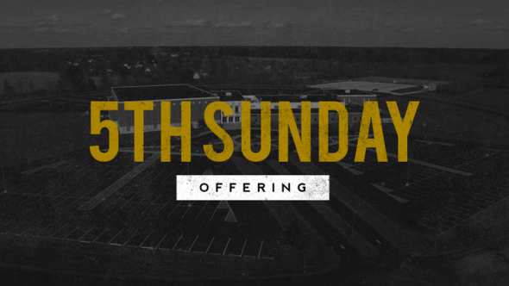

5th Sunday Building Offering
Sunday, December 29, 2019

To underwrite the costs of maintaining our physical plant
so we can continue to offer meaningful ministries,
worship, mission, outreach, and fellowship.

Thank You!

