The congregation is asked to remain silent
during the prelude as a time of prayer and meditation.

GATHERING OF GOD’S PEOPLE
Prelude

Welcome and Announcements
(During this time the friendship pads are passed to be signed)

Minute for Mission

Choral Call to Worship

Call to Worship “Rain Down” Jaime Cortez
Rain down; rain down; rain down your love on your people.
Rain down; rain down; rain down your love, God of life.

Opening Sentences Elder Curt Simpson

Leader: Now is the hour! Let us lift up our hearts in thanks and
praise! For we are called into this place to worship the Lord!
People: Now is the time to feel God's presence in our midst; to
respond to God's claim on our lives; to renew our
commitment of faith.
Leader: As the disciples of old cast aside their nets, so in this hour, we
shed our worldly cares and celebrate life anew!
All: Let us worship God!

*Hymn #487 “When Morning Gilds the Skies” LAUDES DOINI

Prayer of Confession
Almighty God, you desire that your Son, our Savior have first place in our lives. Yet, we so easily relegate him to a lesser place, choosing to live for ourselves and apart from you. You invite us to walk a narrow path and to lead lives worthy of the gospel. Yet, we too often ignore this gracious invitation.We hold grudges, harbor complaints and give the things of this world priority. Forgive us and free us from our self-centeredness. Open our hearts to Christ's reign over all things. Let our lives be worthy of Christ the King, the Prince of Peace, the Redeemer of all. Amen.

*Assurance of Pardon

*Gloria Patri Hymn #579 Glory Be to the Father

PROCLAIMING GOD’S WORD

P.A.T.H. (Presbyterian Answer to Hunger) OFFERING
Children’s Sermon

Anthem Kenny Adams
“There’s a Great Day Comin’ Some Day”

Prayer for Illumination
Almighty God, help us to hear your holy Word this morning. Open our hearts and minds. Upon hearing, help us to grow closer to you, to follow your way and seek your honor and glory in all that we do. In Christ's name we pray. Amen.

Gospel Lesson Elder Curt Simpson
John 1: 10-14 +Page 87

*Hymn #306 “Fairest Lord Jesus” CRUSADERS’ HYMN

Epistle Lesson Colossians 1: 15-20 +Page 188

Sermon “What’s It All About?” Elder Jim Sills

A Time for Silent Reflection

Pastoral Prayer with the Lord’s Prayer

GIVING THANKS TO GOD
Presentation of Tithes and Offering

Offertory

*Doxology and Prayer of Dedication

Praise God from whom all blessings flow;
Praise Him all creatures here below;
Praise Him above ye heavenly host;
Praise Father, Son, and Holy Ghost. Amen.

*The Affirmation of Faith: The Apostles’ Creed

I believe in God the Father Almighty, Maker of heaven and earth, And in Jesus Christ his only Son our Lord; who was conceived by the Holy Ghost, born of the Virgin Mary, suffered under Pontius Pilate, was crucified, dead, and buried; he descended into hell; the third day he rose again from the dead; he ascended into heaven, and sitteth on the right hand of God the Father Almighty; from thence he shall come to judge the quick and the dead. I believe in the Holy Ghost, the holy catholic Church, the communion of saints, the forgiveness of sins, the resurrection of the body, and the life everlasting. Amen.

*Hymn #372 I WANT TO BE A CHRISTIAN
“Lord, I Want to Be a Christian”

*Benediction

*Choral Benediction “Amen” Marty Haugen
Amen, Amen, Amen.

*Postlude

*All who are able may stand. +The page number in pew Bible

SUMMER VESPERS

Friends of Kirkwood will again host Summer Vespers at Camp Kirkwood in Watha, NC (ten miles south of Wallace on Highway 117, turn right on Camp Kirkwood Road and go to camp entrance on your right).

Vesper services begin with fellowship and refreshments under the Picnic Pavilion at 5:00 p.m. Worship begins at 6:00 p.m. in the Vesper Area next to the lake.
The June 8 Vesper Service will be hosted by Oak Plain and Topsail Presbyterian churches.

Summer Schedule:

Sunday, June 8: Hosted by Oak Plain & Topsail PC
Sunday, July 13: Hosted by Faison PC
Sunday, August 10: Hosted by St. Andrews-Covenant PC/Wilmington
Sunday, September 14: Hosted by Wallace PC
Sunday, October 12: Hosted by Burgaw PC



Sanctuary Flowers
If you are interested in putting flowers in the Sanctuary for Sunday morning service, please let Susie Bullard know.
Here are the dates that are available for 2014:
June 8 August 3
June 22 August 10
July 6 August 24
July 13 October 5
July 27 November 2

Flowers do not have to come from the florist. The flowers can be fresh from your yard. Please contact Susie Bullard 910-284-0663 or Susie_bullard@yahoo.com if you are interested.

Sunday, June 1 9:40 am Opening Assembly
10:00 am Sunday School
11:00 am Worship-Jim Sills, preacher
Tuesday, June 3 6:30 am Coffee & Doughnuts, Room 304
7:00 am SonRise Worship Service, Room 304
Wednesday, June 4 10:00 am Bible Study, Room 304
7:30 pm Choir Practice

NOTES AND ANNOUNCEMENT
●
- Thank you to Elders Jim Sills and Curt Simpson for their worship leadership this morning.
- Philip Gladden will return from vacation tomorrow.
- This morning we receive our P.A.T.H. (Presbyterian Answer to Hunger) offering. This offering supports the Hunger Ministry of the Presbytery of Coastal Carolina which, in turn, supports feeding programs in Haiti and Malawi and food pantries in congregations. Our Helping Hands Food Pantry has made application for a grant from the Hunger Committee. Thanks for your generous support.
- Please join the minister for a Bible study on John 7:37-39 and Acts 2:14-21 on Wednesday, June 4 at 10:00 a.m. in Room 304.
- Our Summer Reading Ministry will host an open house for students from Wallace Elementary School and their families on Thursday, June 5, at 6:30 p.m. The Summer Reading Ministry will begin on July 8. If you would like to volunteer, please contact Pat Barrow, Susan Walters, or Harriet Farrior.
- Congratulations to Jackson Gladden and Jonathan Britt who were married yesterday in Southampton, NY.

 NURSERY GREETER
06/01: Rob & Ciria Lanier 06/01: Joey & Rita Brinkley
06/08: Jim & Danielle Sills 06/08: Greg & Sandy Miller
 YOUTH WORSHIP LEADERS 
06/01: Will & Jane Caroline Minchew Charley Farrior, Leader
06/08: Joseph & Colby Phaneuf Curt Simpson Rick Batchelor
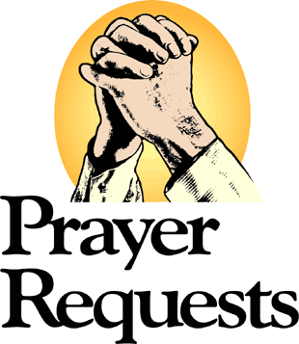
Bill Carone J Parker
Bill Blalock-Rehab-Wilmington, Myree Bland, Avalee Bowman-
The Oaks at Mayview, Raleigh, Tammy Callahan-(Frankie Coleman’s daughter, stroke) Warren Cavenaugh, Brain Tumor, Rose Curth-Brain Cancer, Helen Glass-cancer, Herman Hardy, Ozelle Kennedy-(Joell Parker’s Grandmother), SPC William Krupitzer-(nephew of Linda Burroughs), Wright Lanier family, Pippa Larsen-one year old diagnosed with AAL, a form of leukemia, (friends of Nick & Lee Baker), Sharon Moore, Glenn Powell, Suzanne Powers (part-time resident at River Landing battling cancer), Judy Robinson, Evelyn Shaver, Michael Sumner, Bettisue Tillman-Dayspring, Kelsea Webster, Verlie Wells-Rosemary, Members and friends in the armed services: Jason Payne.

OPENING & CLOSING: June 1-15: Roger Coombs

VACATION BIBLE SCHOOL 2014

Are there any Weird Animals in your home? Maybe you are a Weird Animal! Come find out at our upcoming Vacation Bible School! This year’s VBS "Weird Animals" will be held from 5 to 8 p.m., Monday, June 23 through Thursday, June 26.

We will have fun and fellowship together studying "Weird Animals: Where Jesus’ Love Is One-of-a-Kind.” In this theme, “weird” means special, unique, rare, one-of-a kind. Kids will learn that God filled the world with all kinds of creatures. When kids feel weird, different or even lost in the crowd, nothing compares to the extraordinary love of Jesus.

Since this year's VBS will be held in the evening, the whole family can attend. There will even be activities for adults. To help with this year's VBS, please contact either Curt Simpson at (910) 290-2194 or curt.simpson@gmail.com, or Joell Parker at (804) 366-5663 or joellkennedy@gmail.com.

Philip Gladden will be offering a class for adults, so everyone can join the fun of VBS. We will think about the “Weird Animals” we are called to be as followers of Jesus Christ. What does it mean to be called a Christian? How shall we live in the extraordinary, fantastic love of Jesus Christ?
Here is a sneak preview of the topics for the adult class:

Monday, June 23: We are Aliens and Exiles—1 Peter 2:4-12
Tuesday, June 24: We Are Clay Jars—2 Corinthians 4:1-18
Wednesday, June 25: We Are the Body of Christ—1 Corinthians 12:12-31
Thursday, June 26: We Are Free to Be Slaves—Galatians 5:1, 13-26

WEEKLY CALENDAR

Wallace Presbyterian Church
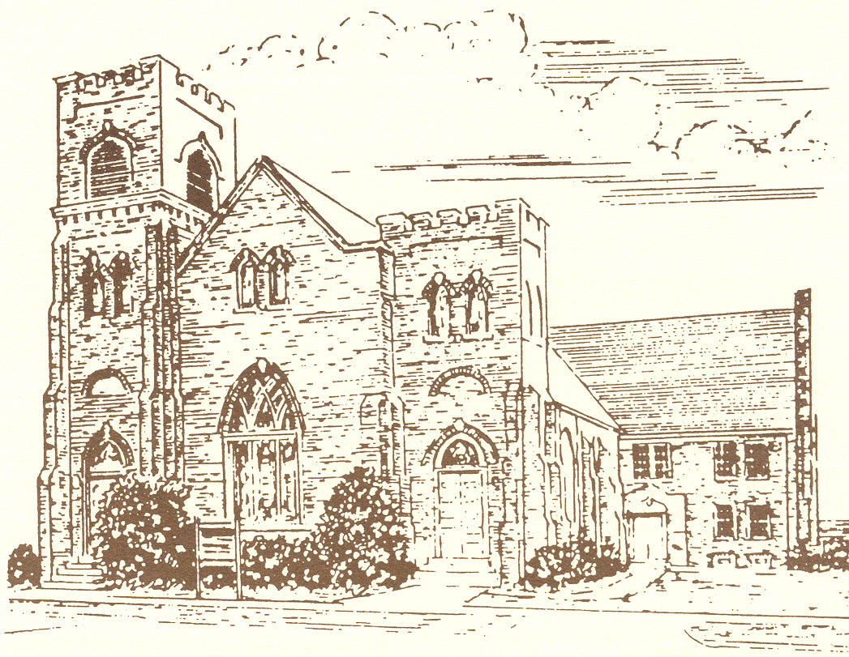
Organized in 1884

THE SERVICE FOR THE LORD’S DAY

June 1, 2014

Eleven O’clock in the Morning

We support Presbyterian Church (USA) mission co-workers,
Rev. Dustin and Sherri Ellington, in Lusaka, Zambia, Africa.

Visit our Website: www.wallacepresbyterian.com

