*The congregation is asked to remain silent*

*during the prelude as a time of prayer and meditation.*

GATHERING OF GOD’S PEOPLE

Prelude

Welcome and Announcements

*(During this time the friendship pads are passed to be signed)*

Minute for Mission

Choral Call to Worship

Call to Worship  **“Rain Down”** Jaime Cortez

*Rain down; rain down; rain down your love on your people.*

*Rain down; rain down; rain down your love, God of life.*

Opening Sentences  Elder Harriet Farrior

*Leader: You have heard what was written about Jesus in Scripture* **—**

*how he would suffer and die**and then rise from the dead on the third day;*

*how the same power that raised Jesus from the dead*

*raised Him to heaven and seated Him at the right hand of*

*God,**where he now lives to intercede on our behalf.*

*So let us come before God with confidence,**through the*

*loving intercession of our risen Lord,**Jesus Christ!*

All: **Our God reigns!**

**Robed with majesty and armed with strength,**

**God holds our world and our lives securely.**

**This is the God to whom we have given our lives —**

**the God who deserves our worship and our praise!**

*Hymn #144 “Alleluia! Sing to Jesus!” HYFRYDOL

Prayer of Confession

*O God of promise and fulfillment, you command us to pray for the coming of your Spirit, and yet we confess a reluctance to watch and wait. O God of power and might, you invite us to pray for the coming of your kingdom, and yet we acknowledge an unwillingness to witness and work. O God of cross and crown, wind and fire, you reveal yourself to us in ordinary and extravagant ways, and yet at times we have not perceived your presence, heard your voice, received your blessing, or shared your love with others. Forgive us, in the name of the One who is seated at your right hand, Jesus Christ our Lord.* ***Amen.***

*(Today’s Prayer of Confession is from Providence United Methodist Church, Charlotte, NC.)*

*Assurance of Pardon

*Gloria Patri Hymn #579 *Glory Be to the Father*

PROCLAIMING GOD’S WORD

FEED THE HUNGRY CHILDREN/BACKPACK MINISTRY OFFERING

Children’s Sermon

Anthem **“Prayer for America”** Eugene Butler

*God of our fathers, we pray today for the nation which our fathers founded.*

*We thank you God for the heritage which has come down to us,*

*Bought by other tears than our own.*

*We thank you for great character that has been woven into the fabric of this nation.*

*Blessed be your name! Blessed be your name! Blessed be your name!*

*For great leaders whom in crucial times you have lifted up to direct our paths.*

*Steady today our hands to grasp the torch of righteousness;*

*That the light of this people may not fail. Amen!*

Prayer for Illumination (Sing in Unison)

*Open the eyes of my heart, Lord. Open the eyes of my heart.*

*I want to see You, I want to see You.*

*Open the eyes of my heart, Lord. Open the eyes of my heart.*

*I want to see You, I want to see You.*

*To see You high and lifted up, Shining in the light of Your glory.*

*Pour out Your power and love As we sing holy, holy, holy!*

*CCLI Song # 2298355 Paul Baloche © 1997 Integrity's Hosanna! Music (Admin. by EMI Christian Music Publishing (IMI)) For use solely with the SongSelect Terms of Use. All rights reserved.* [*www.ccli.com*](http://www.ccli.com) *CCLI License # 1782400*

Old Testament Lesson Elder Harriet Farrior

*Psalm 47* +Page 499

*Hymn   **“We Bow Down”** Paris

You are Lord of creation And Lord of my life,

Lord of the land and the sea.

You were Lord of the heavens Before there was time,

And Lord of all lords You will be.

We bow down And we worship You, Lord.

We bow down And we worship You, Lord.

We bow down And we worship You, Lord.

Lord of all lords You will be.

You are King of creation And King of my life,

King of the land and the sea.

You were King of the heavens Before there was time,

And King of all kings You will be.

We bow down And we crown You the King.

We bow down And we crown You the King.

We bow down And we crown You the King.

King of all kings You will be.

*CCLI Song # 20003 Twila Paris © 1984 New Spring (Admin. by Brentwood-Benson Music Publishing, Inc.) For use solely with the SongSelect Terms of Use. All rights reserved.* [*www.ccli.com*](http://www.ccli.com) *CCLI License # 1782400*

New Testament Lesson +Pages 86, 112

*Luke 24:44-53 and Acts 1:1-14*

Sermon “Wait for It and Pray for It” Dr. Philip K. Gladden

A Time for Silent Reflection

Pastoral Prayer with the Lord’s Prayer

GIVING THANKS TO GOD

RECEPTION AND RECOGNITION OF NEW MEMBER

Presentation of Tithes and Offering

Offertory

*Doxology and Prayer of Dedication

Praise God from whom all blessings flow;

Praise Him all creatures here below;

Praise Him above ye heavenly host;

Praise Father, Son, and Holy Ghost. Amen.

*The Affirmation of Faith: The Apostles’ Creed

*I believe in God the Father Almighty, Maker of heaven and earth, And in Jesus Christ his only Son our Lord; who was conceived by the Holy Ghost, born of the Virgin Mary, suffered under Pontius Pilate, was crucified, dead, and buried; he descended into hell; the third day he rose again from the dead; he ascended into heaven, and sitteth on the right hand of God the Father Almighty; from thence he shall come to judge the quick and the dead. I believe in the Holy Ghost, the holy catholic Church, the communion of saints, the forgiveness of sins, the resurrection of the body, and the life everlasting.* ***Amen.***

*Hymn #40 **“Joy to the World!”**   ANTIOCH

*Benediction

*Choral Benediction  **“Amen”**  Marty Haugen

*Amen, Amen, Amen.*

*Postlude

\**All who are able may stand. +The page number in pew Bible*

American Legion Post 156

Memorial Day Ceremony

Taps For Our Departed Servicemen & Women

Monday, May 26, at 10:00 AM

Conducted Inside Rockfish Presbyterian Church

Located on NC Hwy 41 Just West of Wallace

TAPS

Day is done, gone the sun,

From the hills, from the lake,

From the sky.

All is well, safely rest, God is nigh

Sunday, May 25 9:40 am Opening Assembly

10:00 am Sunday School

11:00 am Worship

Monday, May 26 Memorial Day, Office closed.

Tuesday, May 27-Monday, June 2 Minister on Vacation

Tuesday, May 27 No SonRise Service

Wednesday, May 28 No Bible Study

7:30 pm Choir Practice

**NOTES AND ANNOUNCEMENT**

**●**

* **We welcome** George Francis as a member of our congregation by transfer from The First Church of Christ in Hartford, CT.  George and his wife, Mary, live at River Landing.  He teaches math at James Kenan High School.  Welcome!
* **This morning** we receive the final Feed Our Hungry Children/Backpack Ministry Offering of the 2013-2014 school year. This summer Duplin Christian Outreach Ministries, through the Backpack Ministry, will provide 400 packs of food (40 per week for 10 weeks) for children at four elementary schools (Wallace, Chinquapin, Beulaville, and Rose-Hill Magnolia). Thank you for your generous and faithful contributions!
* **Philip Gladden** will be on vacation Tuesday, May 27 - Monday, June 2. Please contact Susie Bullard, clerk of session, or the church office in an emergency.
* **The church office** will be closed tomorrow, May 26, in observance of Memorial Day.
* **There will be no** Tuesday morning SonRise Worship or Wednesday morning Bible study this week.
* **Elder Jim Sills** will be our preacher next Sunday, June 1.
* **Our congregation** received a $1000 grant from the Committee on Mission and Outreach of the Presbytery of Coastal Carolina for our Summer Reading Ministry.
* **Congratulations** to our Pender County students! Penderlea School 3rd Quarter: Principal’s List (all A’s) — Hill Lanier; A/B Honor Roll — Garrett Bullard. Madison Bullard is a 2014 Pender High Marshal. “If one member is honored, all rejoice together with it.” (1 Corinthians 12:26)
* **We extend** our Christian love and sympathy to Nell Sloan and her family on the death of her brother, David Sloan, in South Carolina on May 20.

** NURSERY  GREETER**

**05/18:** Chuck & Gina Farrior **05/18:** Bill & Susan Carone

**05/25:** Blake & Leah Wallace **05/25:** Thomas & Lois Edgerton

 YOUTH WORSHIP LEADERS 

Bill Blalock-Rehab-Wilmington, Myree Bland, Avalee Bowman-

The Oaks at Mayview, Raleigh, Tammy Callahan-(Frankie Coleman’s daughter, stroke) Warren Cavenaugh, Brain Tumor, Rose Curth-Brain Cancer, Helen Glass-cancer, Herman Hardy, Ozelle Kennedy-(Joell Parker’s Grandmother), SPC William Krupitzer-(nephew of Linda Burroughs), Wright Lanier family, Pippa Larsen-one year old diagnosed with AAL, a form of leukemia, (friends of Nick & Lee Baker), Sharon Moore, Glenn Powell, Suzanne Powers (part-time resident at River Landing battling cancer), Judy Robinson, Evelyn Shaver, Michael Sumner, Bettisue Tillman-Dayspring, Kelsea Webster, Verlie Wells-Rosemary, Members and friends in the armed services: Jason Payne.

**05/18:**  Sarah Pearl Farrior & Hill Lanier  **Joe Tillman, Leader**

**05/25:** Andrew Miller & Tommy NewkirkJim Sills Joey Brinkley

Sam Rose Jonathan Fussell

OPENING & CLOSING: **May 16-31:**  Art Raymond



**VACATION BIBLE SCHOOL 2014**

Are there any Weird Animals in your home? Maybe you are a Weird Animal! Come find out at our upcoming Vacation Bible School! This year’s VBS "Weird Animals" will be held from 5 to 8 p.m., Monday, June 23 through Thursday, June 26.

We will have fun and fellowship together studying "Weird Animals: Where Jesus’ Love Is One-of-a-Kind.”  In this theme, “weird” means special, unique, rare, one-of-a kind.  Kids will learn that God filled the world with all kinds of creatures.  When kids feel weird, different or even lost in the crowd, nothing compares to the extraordinary love of Jesus.

Since this year's VBS will be held in the evening, the whole family can attend. There will even be activities for adults. To help with this year's VBS, please contact either Curt Simpson at (910) 290-2194 or [curt.simpson@gmail.com](mailto:curt.simpson@gmail.com), or Joell Parker at (804) 366-5663 or [joellkennedy@gmail.com](mailto:joellkennedy@gmail.com).

Philip Gladden will be offering a class for adults, so everyone can join the fun of VBS. We will think about the “Weird Animals” we are called to be as followers of Jesus Christ. What does it mean to be called a Christian? How shall we live in the extraordinary, fantastic love of Jesus Christ?

Here is a sneak preview of the topics for the adult class:

Monday, June 23: We are Aliens and Exiles—1 Peter 2:4-12

Tuesday, June 24: We Are Clay Jars—2 Corinthians 4:1-18

Wednesday, June 25: We Are the Body of Christ—1 Corinthians 12:12-31

Thursday, June 26: We Are Free to Be Slaves—Galatians 5:1, 13-26

**WEEKLY CALENDAR**

**Wallace Presbyterian Church**

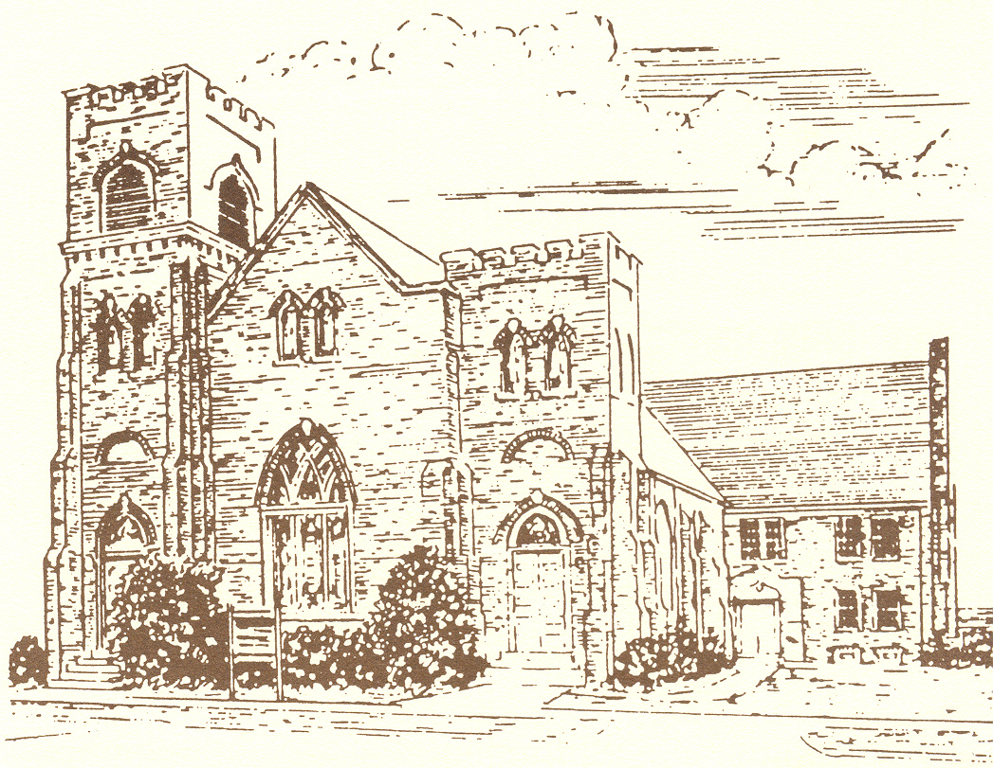

*Organized in 1884*

THE **SERVICE FOR THE LORD’S DAY**

**May 25, 2014**

***Eleven O’clock in the Morning***

**We support Presbyterian Church (USA) mission co-workers,**

**Rev. Dustin and Sherri Ellington, in Lusaka, Zambia, Africa.**

**Visit our Website:** [**www.wallacepresbyterian.com**](http://www.wallacepresbyterian.com)