

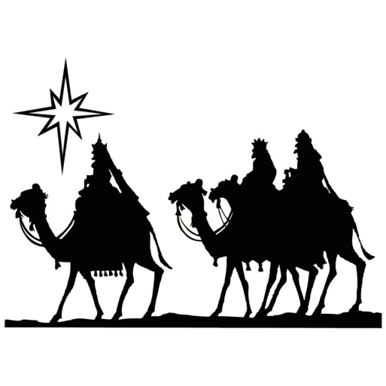
Sunday, January 2 9:30 am Alternative Sunday School Class, in
Person (Room 304) & Zoom
10:00 am Sunday School Classes
11:00 am Worship in person & live stream/The
Sacrament of the Lord’s Supper
Monday, January 3 CHURCH OFFICE CLOSED
10:30 am Circle #1: Earleene Southerland’s home
7:00 pm Zoom Bible Study
Tuesday, January 4 10:30 am Circle #3: Fellowship Hall
7:00 pm Circle #4: Fellowship Hall
Wednesday, January 5 10:00 am Bible Study/in person (304) & via zoom
6:00 pm Handbells
7:00 pm Choir Practice
Thursday, January 6 EPIPHANY OF THE LORD



WEEKLY CALENDAR
WALLACE PRESBYTERIAN CHURCH
205 West Main Street ● Wallace, North Carolina 28466
(910) 285-2808
Visit our Website: www.wallacepresbyterian.com
We support Presbyterian Church (USA) mission co-workers,
Rev. Dustin and Sherri Ellington, in Lusaka, Zambia, Africa.

.

THE SERVICE FOR THE LORD’S DAY
The Sacrament of the Lord’s Supper

January 2, 2022 11:00 a.m.

GATHERING OF GOD’S PEOPLE

Prelude

Welcome and Announcements

Opening Sentences Elder Leader: Arise! Shine! The light you have been waiting for is here!
All: Darkness has been banished!
Leader: God's light of hope floods the earth
All: God's light comes to us all.
Leader: Lord, make us ready to journey to this Light.
All: Prepare our hearts to receive this Light.
Leader: The Magi waited and watched, knowing something wondrous would be happening.
All: We waited for the birth of Jesus; now something wondrous is about to take root.
Leader: The darkness that invaded all lives was banished by the light of that star.
All: The darkness what surrounds us is gone!
Leader: Let us celebrate the bright shining of God's love in our lives.
All: Let us become those who will bring the light of God's love to others. Amen.

*Hymn #151 (verses 1,2,3) ”We Three Kings of Orient Are” KINGS OF ORIENT

*Unison Prayer of Confession
Almighty and merciful God, we confess that we have sinned against you and one another in both our actions and our inactions. We recognize that in Jesus our light has come, yet often we choose to walk in the shadows and ignore the light. Gracious God, forgive our sins and remove from us the veil of darkness which shrouds our lives. Illumine us by your Word so we may shine with the radiance of Christ's glory. Lord, hear our prayers . . .

(A time for silent prayers of confession . . .)

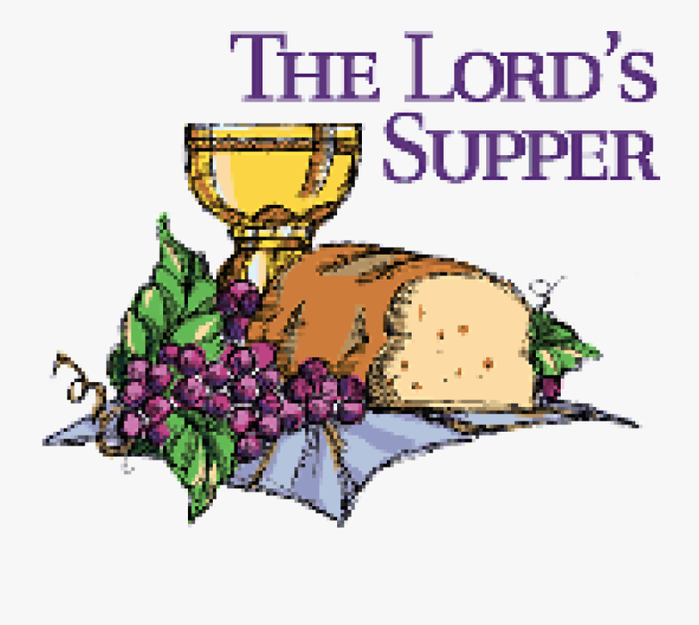

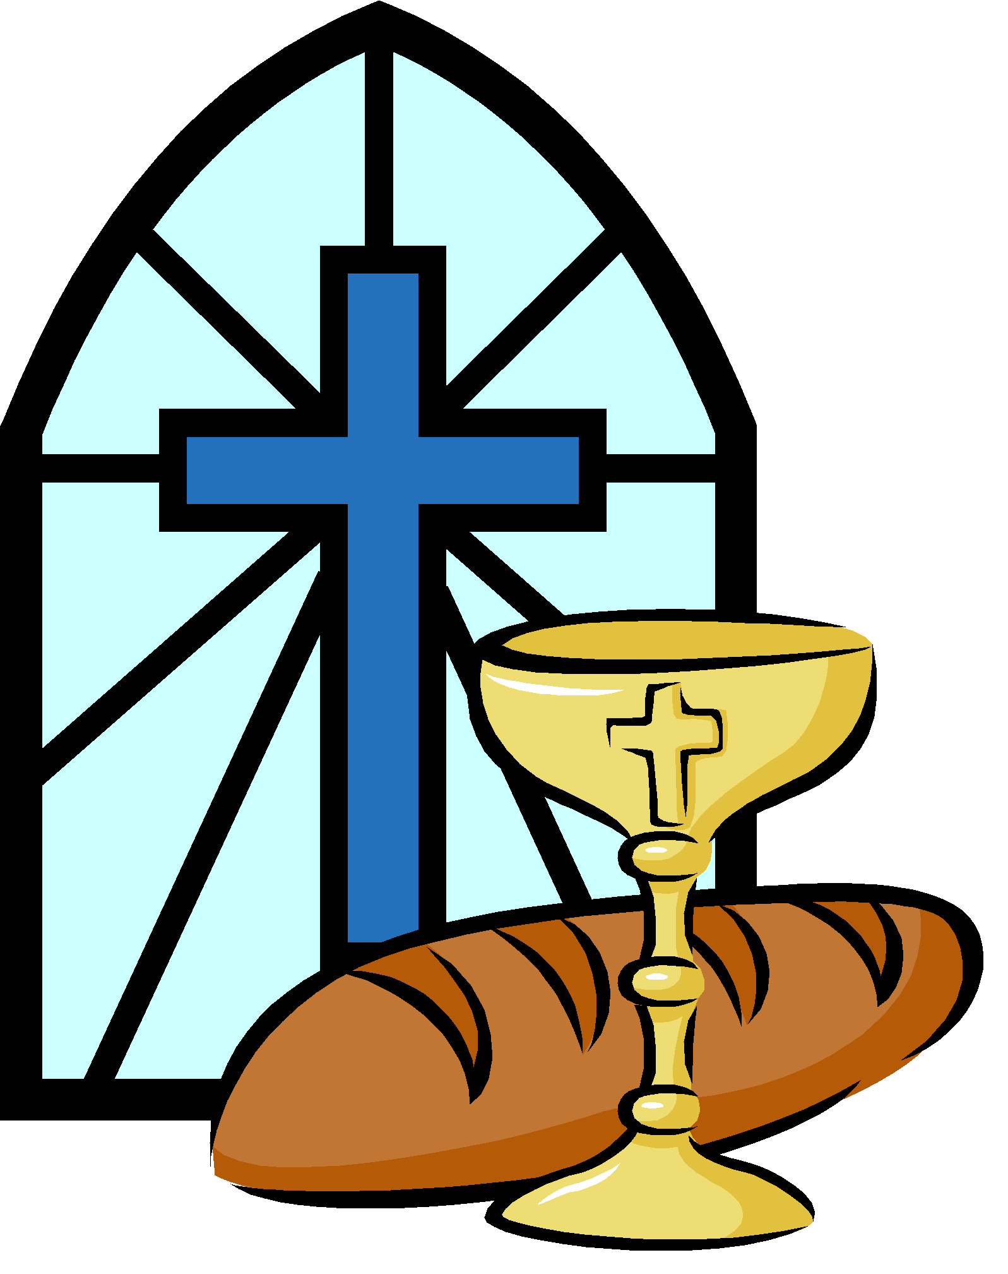

* This morning we celebrate the Sacrament of the Lord’s Supper. All are invited to the table.

* The church office will be closed Monday (tomorrow) January 3.

* Please join the minister for Bible study on either Monday night, January 3 from 7:00 - 8:00 p.m. via Zoom or Wednesday morning, January 5 in person (Room 304) or via Zoom. This week we will read and talk about John 1:19-34. Zoom links will be emailed on Monday, January 3.

NOTES AND ANNOUNCEMENTS
NOTES AND ANNOUNCEMENTS



The congregation is asked to remain silent during the prelude as a time of prayer and meditation.

“God’s bright star, o’er his head, wise men three to him led; kneel they low by his bed, lay their gifts before him, praise him and adore him. Gloria in excels is Deo!”
Hymn #141, “On This Day Earth Shall Ring”

“So bring him incense, gold, and myrrh, come, one and all, to own him. The King of kings salvation brings; let loving hearts enthrone him.”
Hymn #145, “What Child Is This”

*Responsive Assurance of Pardon

Leader: Lift up your eyes and see the grace of God poured out into your lives.

All: The light of God shines through the darkness. Our hearts rejoice for Christ is in our midst.

Leader: Believe the Good News!
All: In Jesus Christ, our sins are forgiven. Thanks be to God for his indescribable gift!

Gloria Patri Glory Be to the Father
Glory be to the Father, and to the Son, and
to the Holy Ghost; as it was in the beginning,
is now, and ever shall be, world without end. Amen, amen.

PROCLAIMING GOD’S WORD

Children’s Sermon

Prayer for Illumination
God of Light and Life, grant us your Holy Spirit, that we may always seek you and your kingdom. Enable us to follow your holy Word, as those from the East followed the leading of a star. Give us grace at all times and in all places to confess your holy name. Amen.

Old Testament Lesson Isaiah 60:1-7 Elder

Gospel Lesson Matthew 2:1-23

Sermon “We Five Kings” Dr. Philip K. Gladden

A Time for Silent Reflection

GIVING THANKS TO GOD

*Presentation of Tithes and Offerings

Offertory

*Doxology and Prayer of Dedication
Praise God from whom all blessings flow;
Praise Him all creatures here below;
Praise Him above ye heavenly host;
Praise Father, Son, and Holy Ghost. Amen.

The Affirmation of Faith: The Apostles' Creed
I believe in God the Father Almighty,
Maker of heaven and earth.
And in Jesus Christ his only Son our Lord;
who was conceived by the Holy Ghost,
born of the Virgin Mary, suffered under Pontius Pilate,
was crucified, dead, and buried; he descended into hell;
the third day he rose again from the dead;
he ascended into heaven, and sitteth on the right hand
of God the Father Almighty; from thence he shall come
to judge the quick and the dead.
I believe in the Holy Ghost; the holy catholic Church;
the communion of saints; the forgiveness of sins;
the resurrection of the body; and the life everlasting. Amen.

The Sacrament of the Lord’s Supper
The Invitation to the Table
The Words of Institution
The Great Prayer of Thanksgiving with the Lord’s Prayer

Our Father who art in heaven, hallowed be thy name. Thy kingdom come, thy will be done, on earth as it is in heaven. Give us this day our daily bread; and forgive us our debts, as we forgive our debtors; and lead us not into temptation, but deliver us from evil. For thine is the kingdom and the power and the glory, forever. Amen.

The Eating of the Bread and the Drinking of the Cup
The Prayer after Communion

*Hymn #151 (verses 1,4,5) ”We Three Kings of Orient Are” KINGS OF ORIENT

*Benediction

*Postlude *All who are able may stand.



“Magi came and gifts unbound, signs mysterious and profound: myrrh and frankincense and gold gave and God and king foretold.”
Hymn #156, “Sing of God Made Manifest”

“O star of wonder, star of night, star with royal beauty bright, westward leading, still proceeding, guide us to thy perfect light!”
Hymn #151, “We Three Kings of Orient Are”

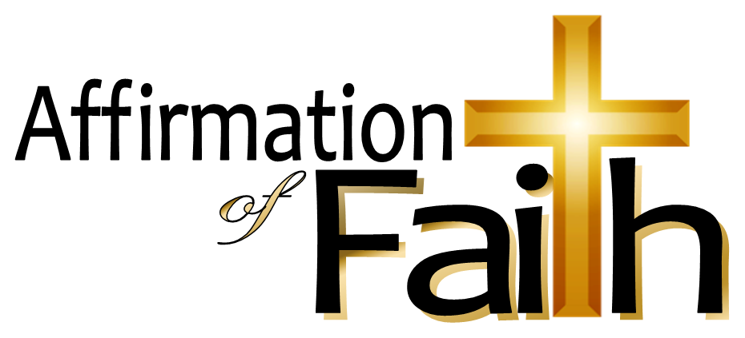

“While outward signs the star displays, an inward light the Lord conveys and urges them, with tender might, to seek the giver of the light.”
Hymn #152, “What Star Is This, with Beams So Bright”

“The magi were wise men who brought gifts to the Babe in the manger. They invented the art of giving Christmas presents.”
O. Henry, The Gift of the Magi

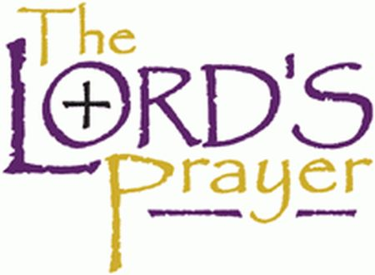

“Wondrous star, lend thy light; with the angels let us sing Alleluia to our King: Christ the Savior is born; Christ the Savior is born.”
Hymn #122, “Silent Night, Holy Night”

